1.create an folder

. direct the folder on vs coder

. check all version

node –v

npm –version

express –v

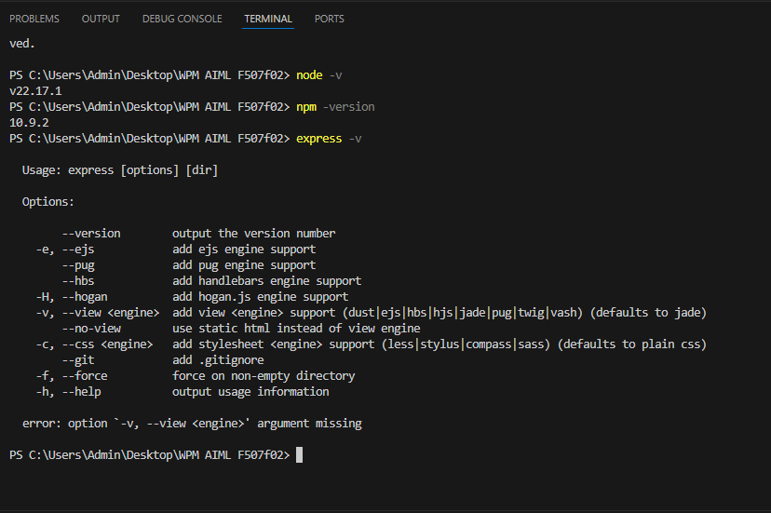

2. to get a dependence

1. npm install –g express –generator

2. express

Can see few folders and file where added

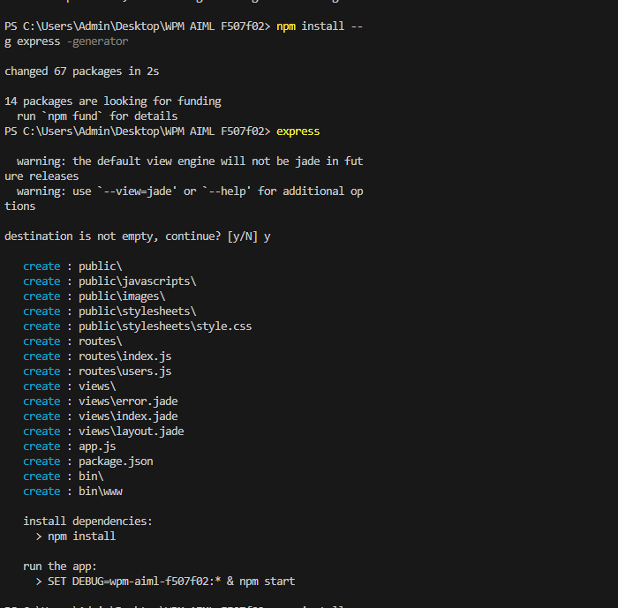

3. $ npm install

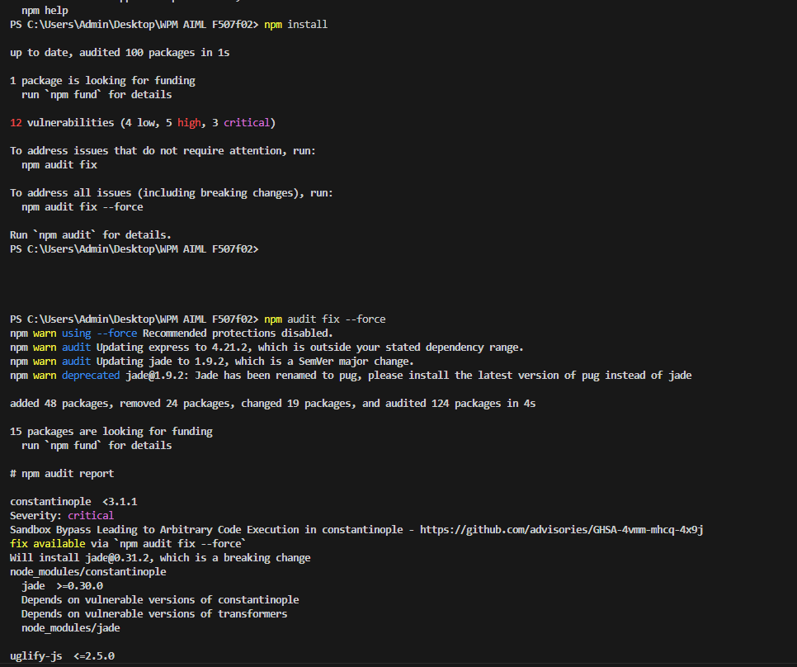

To get an 0 vulnerabilities

Cmd: $npm audit fix –force

Repeat the command till 0 vunerabilities

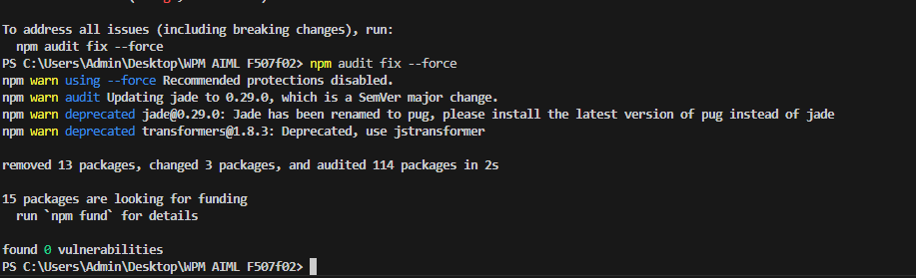

4. $ SET DEBUG=archanaloc8r(your folder name):\* ; npm start

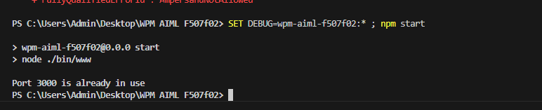

5.next go to google web site localhost:3000

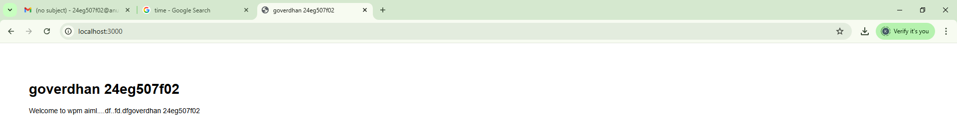

6. npm install -g nodemon

1. nodemon

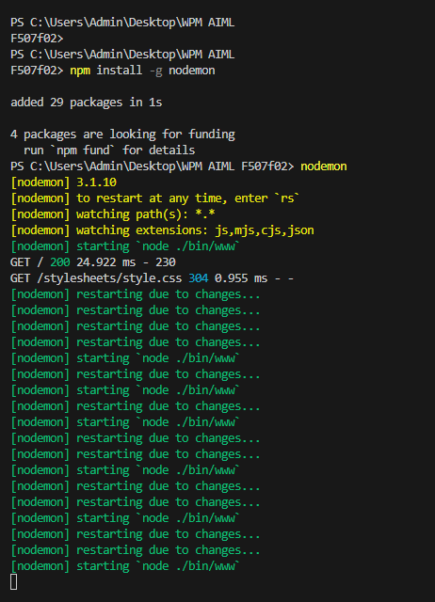

3.create MVC architecture:-

\* create a folder and name it as app server in your folder.

\* Then create 2 new folders in app server folder.

\* Name it as controllers and modules.

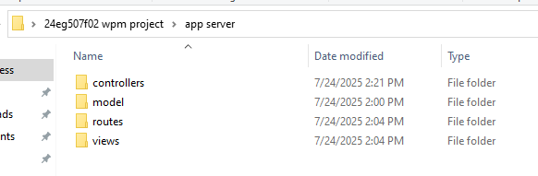

4. Move roots and views into app server folder.

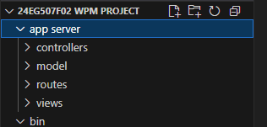

5.open app server under controlers and create a main.js file.

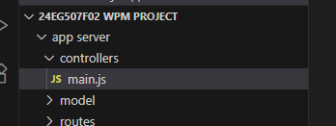

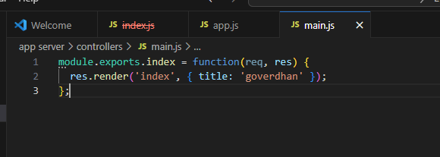

* Write the code in main.js and edit the app server name in app.js

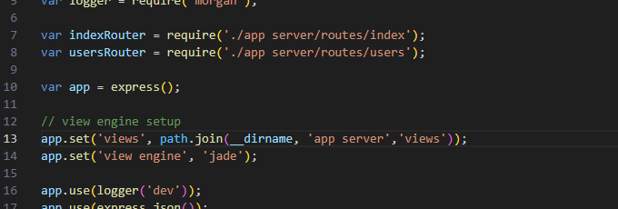

* Go to bootstrap.min file and copy it

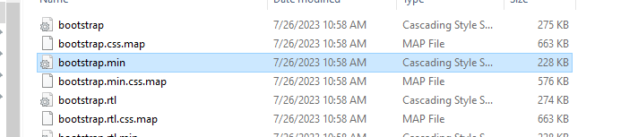

* Paste it in a public , style sheet

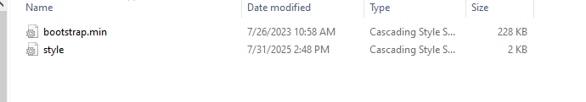

* Past the code from mail to style.css in vs coder

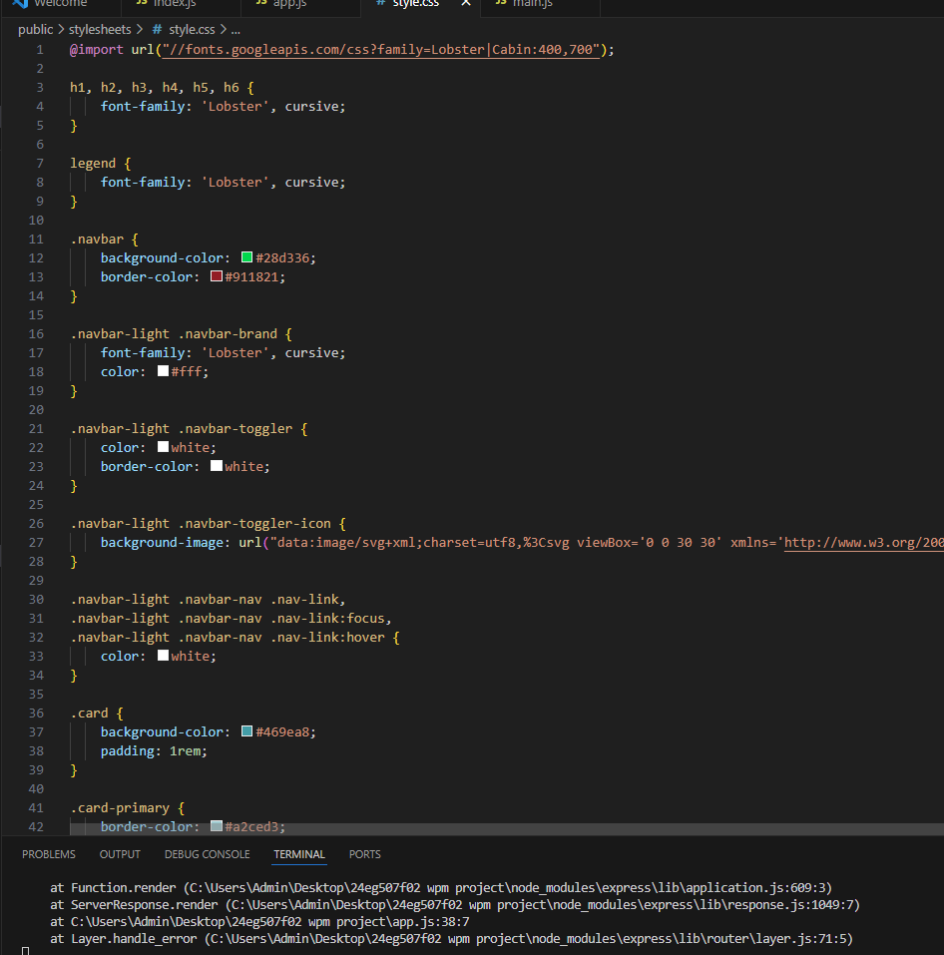

* Check it in localhost3000

